Central Bank Digital Currencies
Complementing Cash and Crypto

Cryptocurrencies have erupted onto the financial scene over the past decade, but they remain a largely divisive topic in the financial industry regarding the stability, application and regulation of the $1.4 trillion market [1]. However, the impact of the cryptocurrencies, and more the use of distributed ledger technology more broadly, along with the increasing digitisation of payments, has prompted over 86% of central banks to investigate the possibility of launching their own Central Bank Digital Currency (CBDC) [2]. In this article, we explore what is driving the need for CBDCs, the impact they may have on the future of money and the technology that could enable Central Bank Digital Currencies.
What Makes CBDCs Unique?
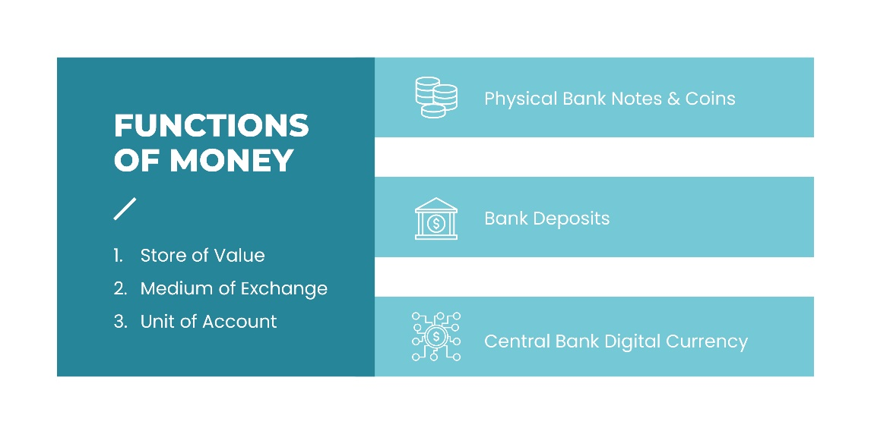
A Central Bank Digital Currency, very simply put, is electronic central bank currency that would exist alongside cash and bank deposits. While the design of each CBDC may differ, the digital currency will be denominated in its national currency as legal tender and backed by the Central Bank. CBDCs have both retail (household and business) and wholesale (interbank) application, however, many central banks are focused on retail payment opportunities, considering commercial banks already have access to electronic central bank reserves through pre-existing infrastructure.
At first glance, the idea of CBDCs may seem redundant, since digital money already exists in the form of bank deposits with banks offering a variety of further benefits and services to customers. Additionally, private cryptocurrencies are already becoming increasingly ubiquitous, with companies such as Amazon and Facebook preparing to launch their own cryptocurrencies and with more and more businesses beginning to accept cryptocurrencies as payment.
The most ubiquitous cryptocurrencies at present, including Bitcoin and Ethereum, are digital assets used as a medium for peer-to-peer payments without a centralised third party to facilitate processing, clearing and settlement. The absence of any authorised intermediary to oversee the transaction is enabled through the use of distributed ledger technology and robust cryptography – secure communication for authentication. However, they are not representative of any underlying asset or backed by the credit worthiness of a government and are often considered as digital commodities (stores of value) rather than effective mediums of payments, due to their high volatility and subsequent rapid price fluctuations.
This has led to the invention of stablecoins – private digital currencies that link their value to other assets or are algorithmically controlled to manage supply and price. Stablecoins are somewhat of a concern for central banks with many authorities investigating the impact of a possible widespread adoption specifically for cross border payments. Central banks worry that the widespread supply of stablecoins could impact their ability to effectively manage monetary policy and may introduce operational instability into the payments industry if not properly regulated. Stablecoins have come under scrutiny lately with regulators highlighting concerns over their ‘self-proclaimed backing verifications’, while not maintaining sufficient controls and capital reserves [3].
Despite the advances in digital crypto-assets recently, the majority of central banks have determined them to be niche products with limited application at this time. Central banks’ current engagement in digital currencies are not driven by the threat of private currencies but rather the opportunities for:
• Payment Efficiency
• Financial Stability

Payments Using CBDCs
The total retail digital payment transactional value for fiat currency is expected to grow by 12% annually over the next five years to $10.5 trillion [4]. Central banks, often responsible for the payment and settlement infrastructure, have realised that stable, ubiquitous digital currencies are needed to support this trend and ultimately, to mitigate systemic risk by providing an alternative to card and online wallet payments that is not reliant on the current payment infrastructure. As these digital currencies are designed to be legal tender, nationwide adoption of these payment options are expected to be much swifter than the adoption of private cryptocurrencies thus far.
Nowhere is this trend clearer than in China, where the People’s Bank of China is aiming to launch their ‘digital renminbi’ or ‘e-yuan’ that will compete with the nation’s powerhouse private payment service providers – Alipay and WeChat. The Chinese government hopes to have its CBDC operational for the 2022 Winter Olympics and has its sights set on ultimately unseating the US dollar in international trade settlement with its new digital currency.
The environment of cross-border payments could be set to experience significant change through the use of a wholesale, interconnected CBDC platform. Currently cross-border payments are expensive, inefficient and opaque due to a combination of varying time zones, regulatory requirements and infrastructural and operational differences across geographical regions. This has many unintended consequences for bank liquidity to meet its obligations during service times. Additionally, cross-border payments rely on the correspondent banking model, whereby financial institutions need to rely on institutions within a region to complete a transaction on their behalf, if they do not have a presence in that particular country. These networks are now on the decline.
While wholesale-CBDC (w-CBDC) cross-border payment models are still very much conceptual or pilot projects, the Bank of Canada, Bank of England and Monetary Authority of Singapore [5] have collaborated to outline three possible scenarios for w-CBDC cross-border payments where the resulting unified payment platform would allow for increased interoperability, operational efficiency and transparency.
However, it is important to note that it is the implementation of a redesigned cross border payment platform, without the trappings of the current Real Time Gross Settle systems used by Central Banks, that will ultimately enable these benefits. Such a system would feature 24/7 availability, alignment of technical standards and greater payment tracking capabilities, whilst making use of digital central bank currency reserves that exist today in wholesale transactions.

Financial Stability Through CBDCs
The primary purpose of central banks is to maintain the financial and price stability of their jurisdictions through monetary policy. Unsurprisingly, these banks hold the sole responsibility to control the supply of money into their economies by either minting physical bank coins and notes for public distribution or managing the reserves of commercial banks through interest rate adjustments to indirectly impact the supply of money.
CBDCs are seen by Central Banks as another tool in their arsenal to fulfil their stability mandate and will look to use CBDCs for a range of uses including:
Removing Credit Risk
CBDCs sit as liabilities on the central bank’s balance sheet giving users a direct claim on the central bank which mitigates any credit risk. Bank deposits held by private institutions will always include an element of credit risk (mitigated through depositor insurance), while cryptocurrencies are often only backed by the technology that underpins them.
Improving Monetary Policy Intermediation
Remunerated CBDC (interest bearing) would allow for the direct transmission of monetary mechanisms such as interest rate adjustments to households and businesses. Remunerated CBDCs would exist as a substitute to bank deposits, compelling commercial banks to adjust their lending rates in connection with remunerated CBDC rates.
However, this could potentially lead to disintermediation, whereby funds are withdrawn from commercial bank deposits and placed into CBDCs thereby shrinking bank balance sheets. This would lead to increased bank lending rates to compensate for lost funds, as well as weakening banks’ capital holdings, which ultimately weakens the transmission of monetary policy through the banking system.
Governing Payment Transactions
CBDCs will be supervised and monitored by the central bank, ensuring the currency itself, the payment system infrastructure and auxiliary services, such as the ones offered by third party payment providers, operate effectively to support financial stability and payments capabilities within the necessary security and data management frameworks.
CBDCs would need to comply with AML and CFT regulations and would have some degree of KYC functionality that is often missing from private cryptocurrencies. To function effectively as a legitimate currency, the high level of anonymity associated with private cryptocurrencies would have to be reduced in order to prevent criminal organisations from using CBDCs for illicit means.
Underlying Technology
Digital currencies are synonymous with distributed ledger technology (DLT). Cryptocurrencies like Bitcoin do not require a trusted third-party to clear and settle peer-to-peer transactions, allowing it to operate without a centralised authority. The ledger, a record of all the transactions and the overall supply of the currency, is maintained across multiple, decentralised nodes (computers). Nodes compete to process transactions that eventually results in the clearing and settlement of the transaction through the addition of an immutable block to the blockchain ledger; with the use of a “consensus protocol” to ensure synchronicity as the ledger is updated. This technology ensures that the process meets the requirements of security, as a result of its consensus protocol and cryptography processes, as well as remaining perpetually available thanks to the decentralisation of transaction processing. For these reasons, DLT is considered to be exceptionally resilient.
However, it is not the only option available to central banks, with most payment infrastructure having previously been built on centralised ledger operations, which have proven to be able to process large volumes of transactions quickly and efficiently – something that decentralised technology has yet to match on a large scale. These efficiencies should drive transactional cost efficiencies for CBDC transactions, allowing Central Banks to further their financial inclusion ambitions by charging less per transaction than card payments.
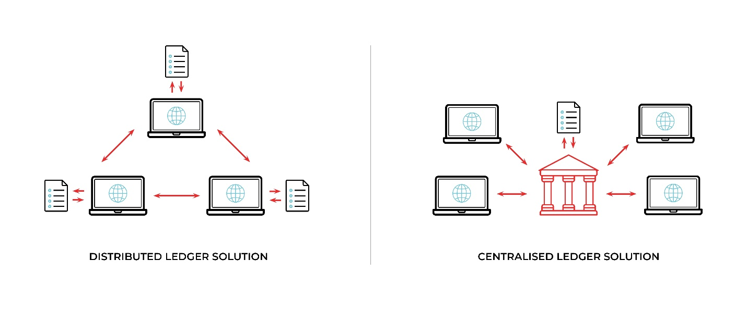
Digital currencies also provide the opportunity for the use of programmable money through the use of smart contracts, whereby payments can be self-executed based on a series of pre-defined conditions.
Ultimately CBDCs are not being designed to replace private cryptocurrencies or physical cash, but rather to advance payment efficiencies both domestically and internationally, whilst ensuring that the role of money in society continues to provide financial stability. While CBDC development is still in its infancy across most of the world, the sharp rise of cryptocurrencies like Bitcoin, the South African Reserve Bank’s recent “flavour of the year” announcement regarding advanced technologies, such as DLT, and the recent developments regarding China’s e-Yuan are all indications that digital currencies are gaining momentum and will no doubt continue to transform the world of money in the 21st century.

[1] The Economist, ‘Tether is fined by regulators in New York’, 2021, https://www.economist.com/finance-and-economics/2021/02/23/tether-is-fined-by-regulators-in-new-york
[2] BIS, ‘Ready, steady, go? – Results of the third BIS survey on central bank digital currency’, 2021, https://www.bis.org/publ/bppdf/bispap114.htm
[3] The Economist, ‘Tether is fined by regulators in New York’, 2021, https://www.economist.com/finance-and-economics/2021/02/23/tether-is-fined-by-regulators-in-new-york
[4] Statista, ‘Digital Payments’, 2021, https://www.statista.com/outlook/dmo/fintech/digital-payments/worldwide
[5] Bank of Canada, Bank of England, Monetary Authority of Singapore, ‘Cross-border interbank payments and settlement, 2018, https://www.bankofengland.co.uk/news/2018/november/boe-boc-mas-joint-report-digital-transformation-in-cross-border-payments

